
AMERICAN INTERNATIONAL UNIVERSITY-BANGLADESH
Faculty of Science and Technology
Department of Computer Science
CSC 3215: Web Technologies

Semester: Summer 2025-26 | Group No: 03 |  | Section: | L

Group Members:
SL. | Student ID | Name | Role | Signature
1 | 23-51689-2 | Md. Muhaimenul Islam | Group Leader | Mahir
2 | 23-51684-2 | Sanjida Tasnim Mithila | Member | Mithila
3 | 23-51720-2 | Taiyeb Tausif Dhrubo | Member | Dhrubo
4 | 23-51598-2 | Md Arfan Rahman | Member | Tonmoy
Project Title
Resell-Market Management System
Short Description
The present project is an online resale marketplace system. Users can purchase and resell used goods via this web system, like mobiles, furniture, small electronic items, etc. There are four different types of users in this system: admin, buyer, seller, and deliveryman. The sellers will be able to add their products to the system, the buyers will be able to order and pay for the products, while the deliverymen will be able to manage and monitor the delivery process. This project is developed using PHP using MVC (Model-View-Controller) architecture and MySQL database management system.
Introduction
Currently, there is a lot of people who tend to prefer purchasing and selling used goods instead of newly purchased ones as it saves their money and prevents wastage. However, people continue to use some informal ways to perform transactions such as placing the information on social media groups. Our product, Resell Market system, resolves this issue providing a platform for purchasing and selling used goods.
Our Resell Market system includes four types of users who have different functions. A seller can post products that he/she wants to sell. A buyer can view the available products, place orders, pay and provide feedback. A delivery man can control the process of delivery of the order and its status. Admin can control the whole system through the approval of new products and user management.

Background Study
Before starting this project, we reviewed the way of functioning of standard online marketplaces and resell platforms. Many popular platforms, for example, eBay or Facebook Marketplace, allow selling items through their platform but are constructed for wide use and contain a lot of additional components which are not necessary for the creation of a resell system. Besides, we also reviewed the MVC (Model View Controller) design pattern that divides any application into three components – Model (responsible for data handling and databases), View (responsible for handling UI) and Controller (responsible for business logic and connection between Model and View). Such design pattern makes the implementation of the project easier, that is why we decided to use it in this project.
Moreover, we reviewed the most widespread features which must be used in any resell platform, namely user roles, product approval systems, orders, payment systems, delivery. On the basis of this research we implemented our resell system and designed it using four different roles of users and constructing appropriate database tables (users, products, orders, payments, reviews, invoices, notifications, drivers, deliveries).
ER Diagram
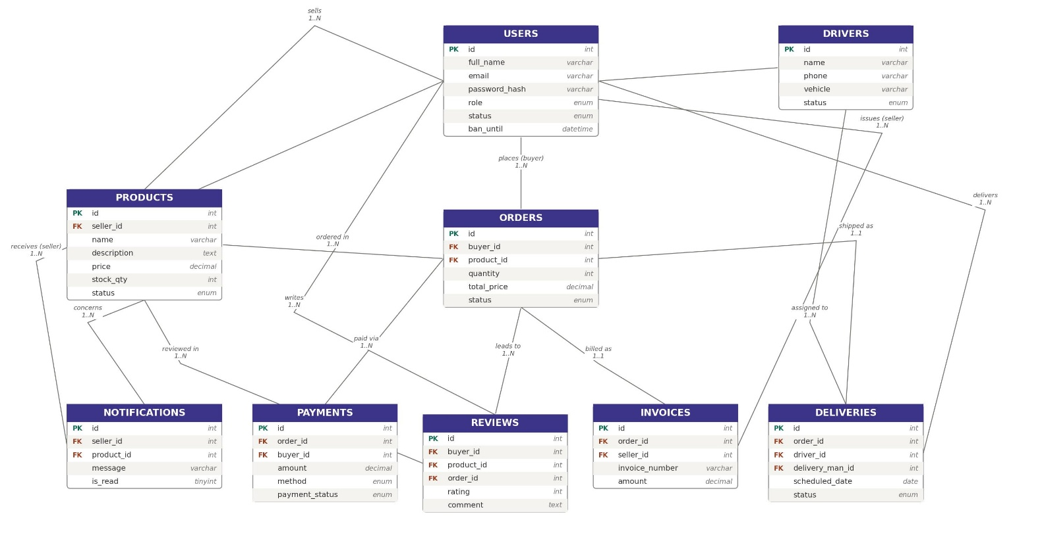
Figure 1: ER Diagram

Use Case Diagram
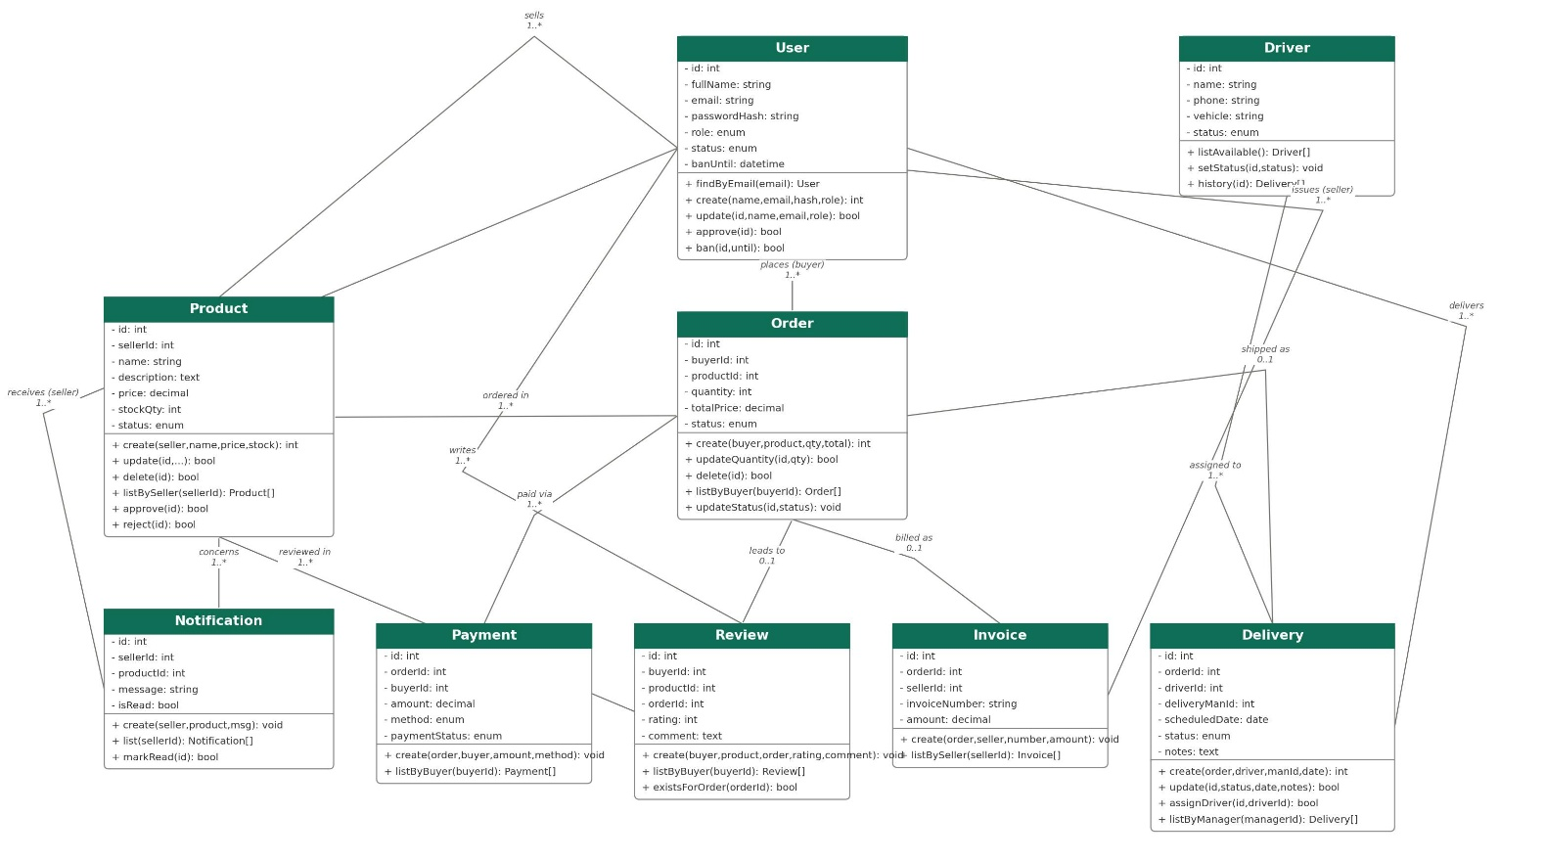
Figure 2: Class Diagram.
UI (Figma/Sketch)
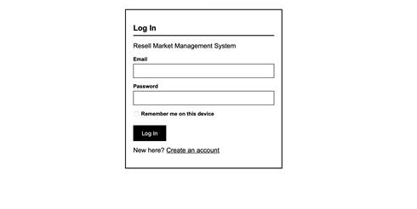
Figure 3: Login Page
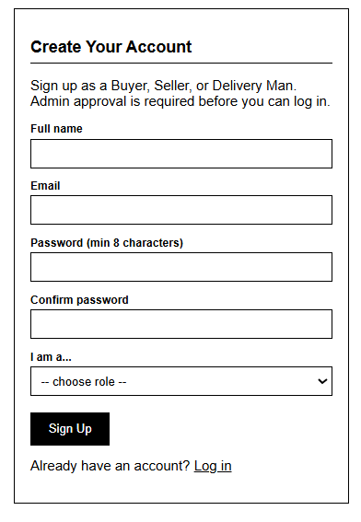
Figure 4: Sign Up

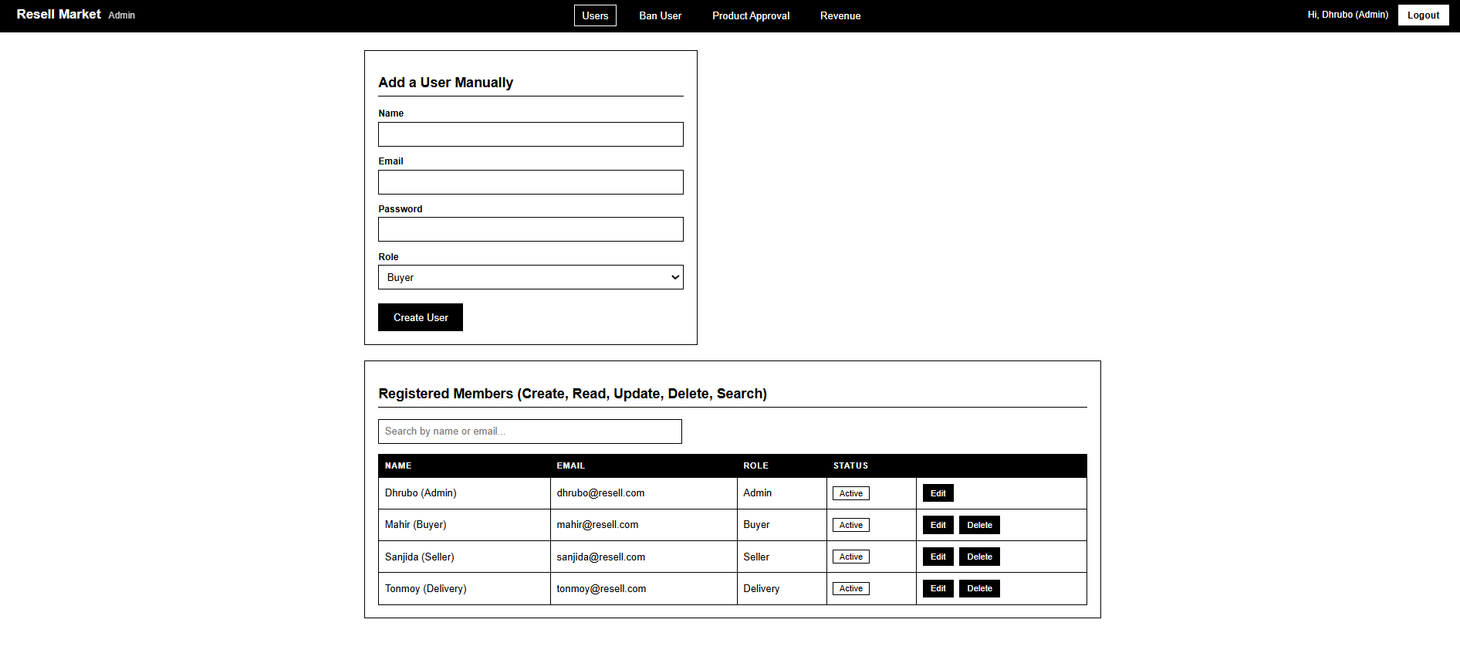
Figure 5: Admin(add user)
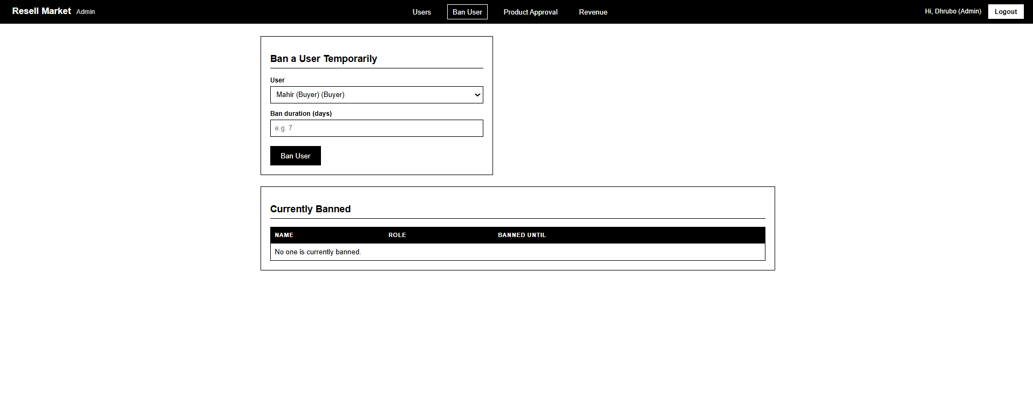
Figure 6: Admin(ban user)
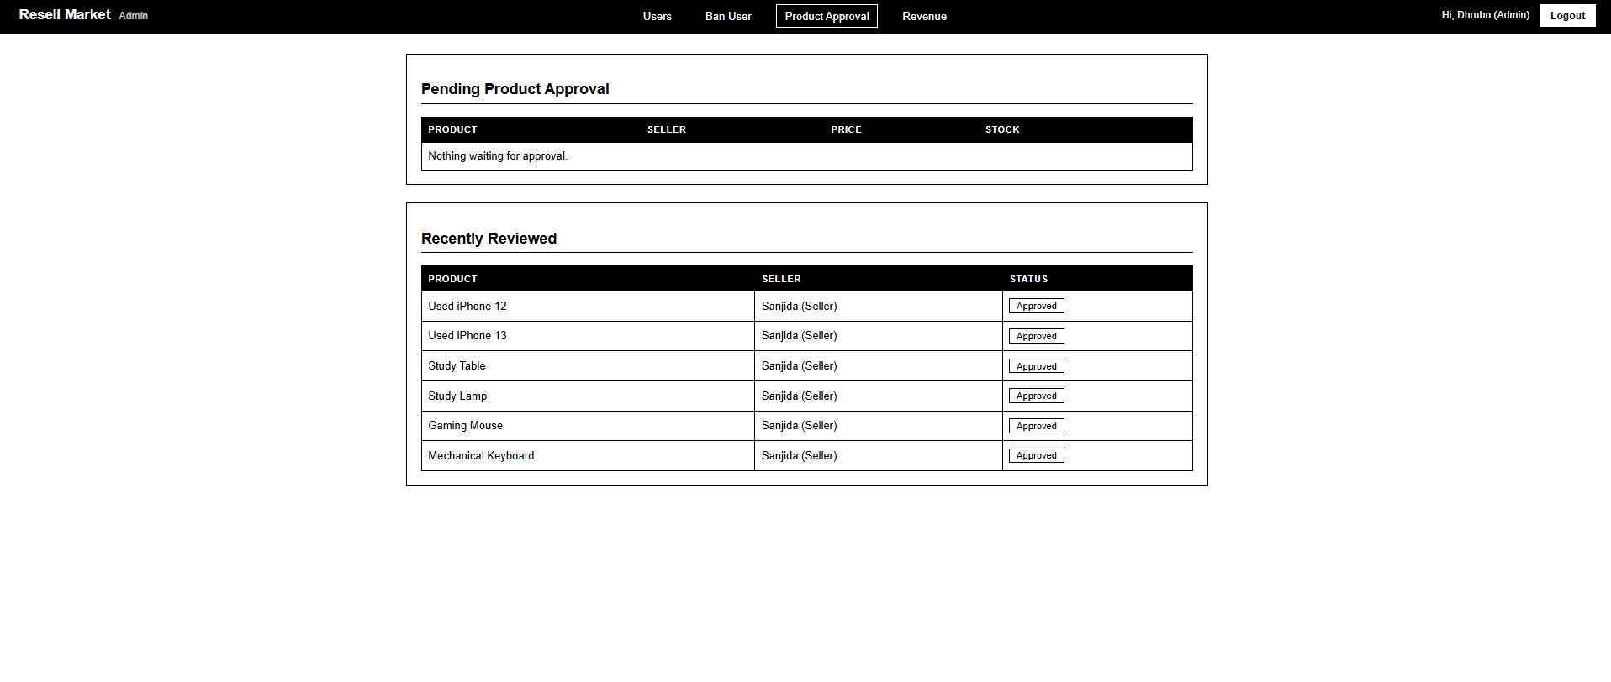
Figure7: Admin (Product Approval)
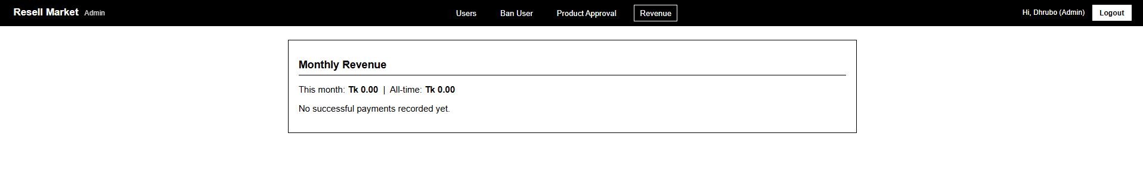
Figure 8: Admin(Revenue)

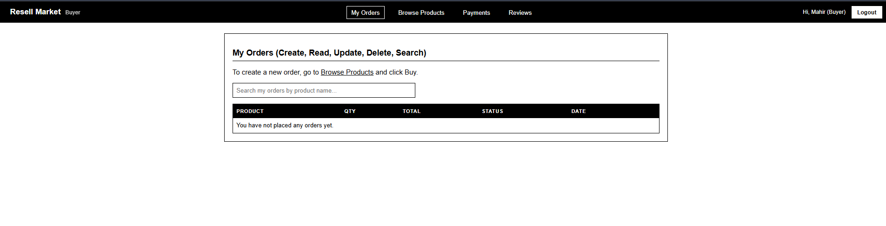
Figure 9: Buyer(My Orders)
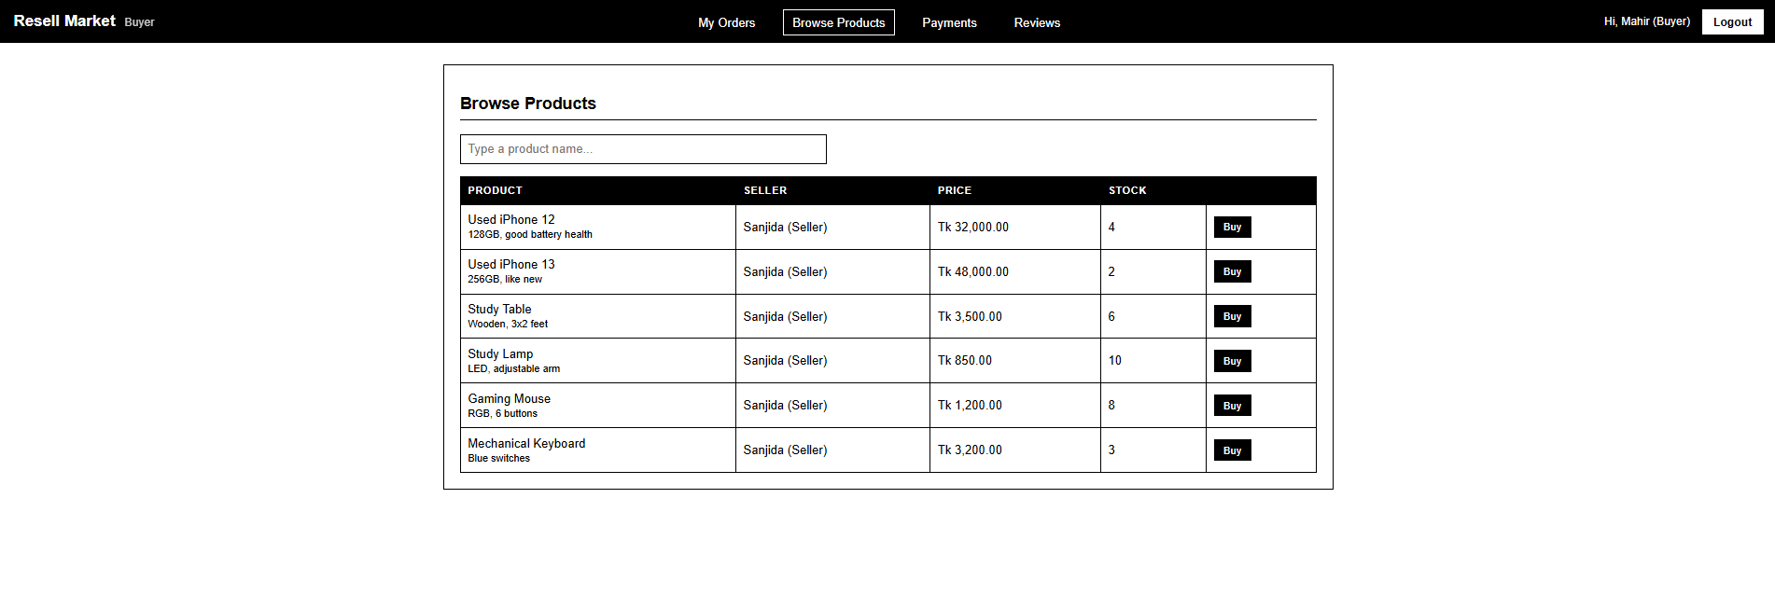
Figure 10: Buyer(Browse products)
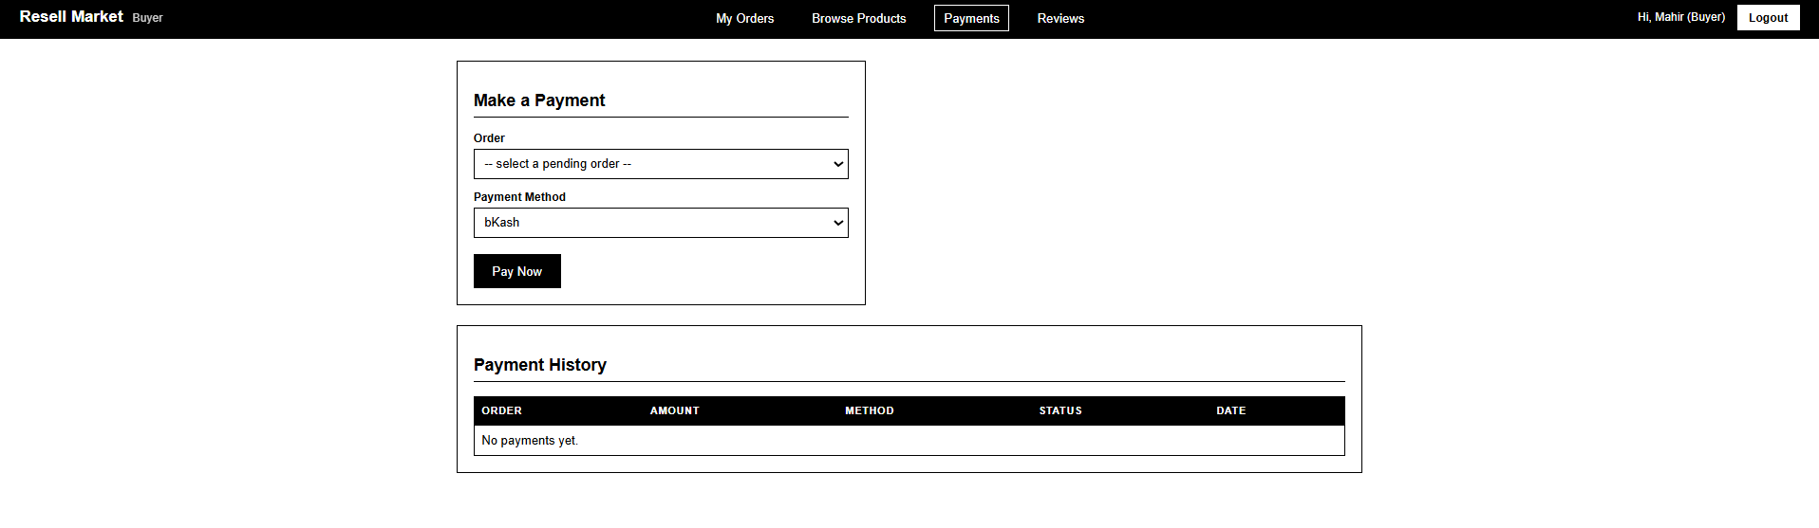
Figure 11: Buyer(Payment)

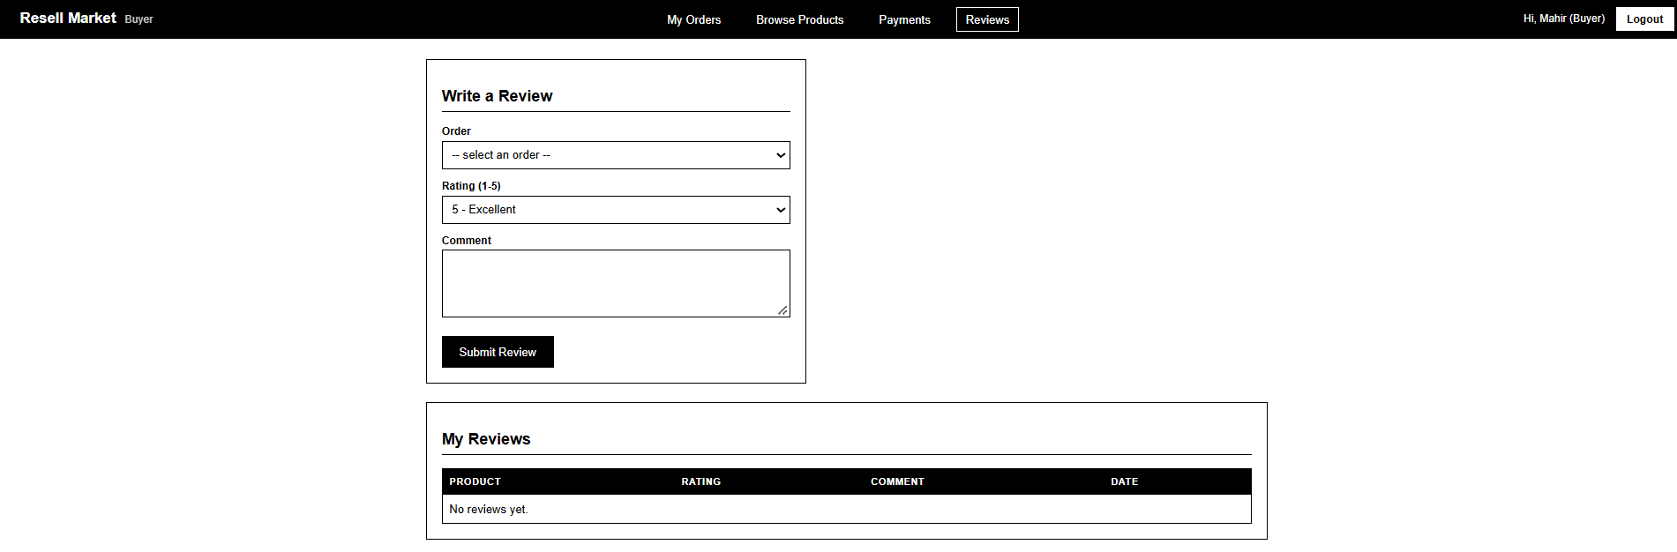
Figure 12: Buyer(Review)
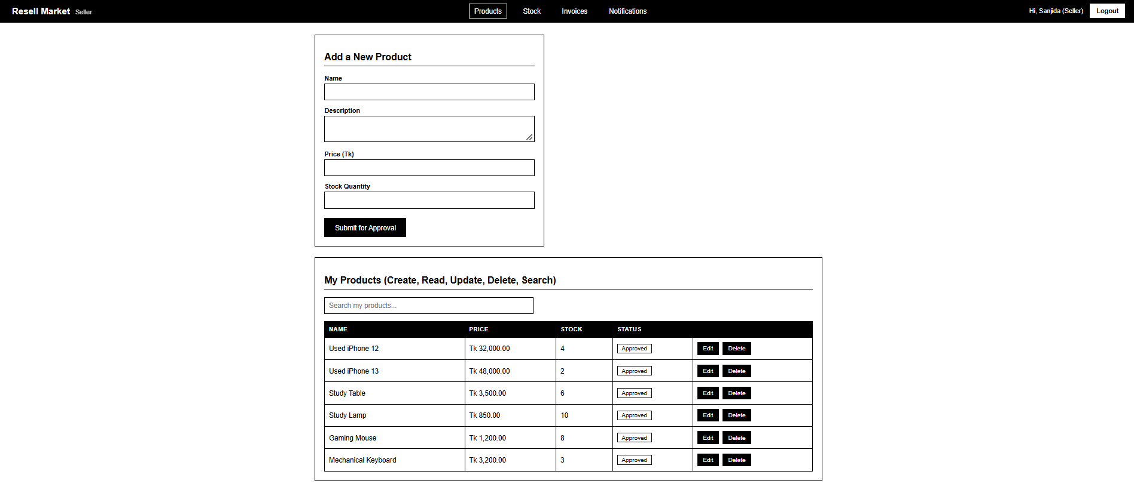
Figure 13: Seller(products)
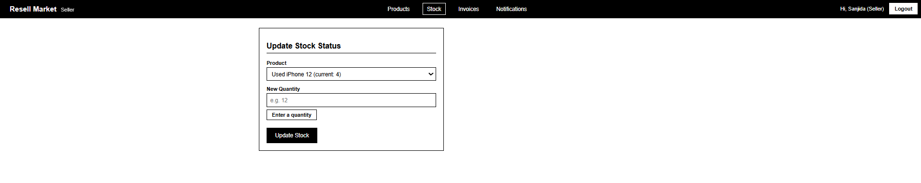
Figure 14: Seller(Stock)
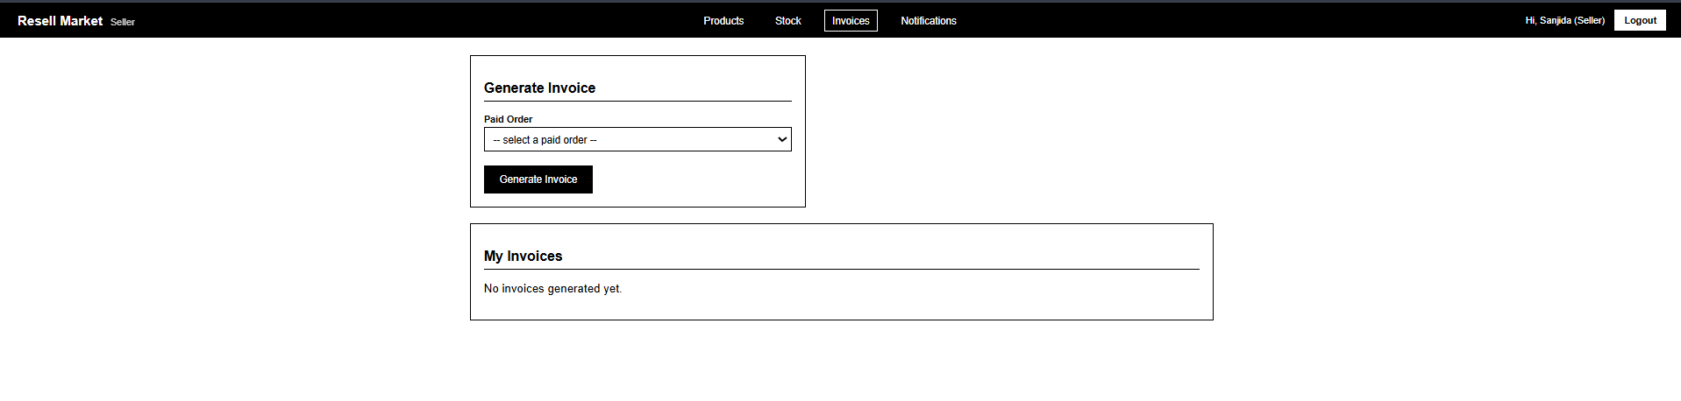
Figure 15: Seller(Invoice)
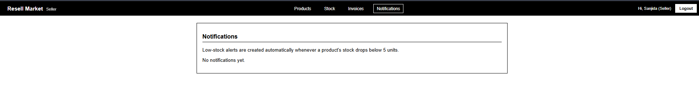
Figure 16: Seller (Notifications)
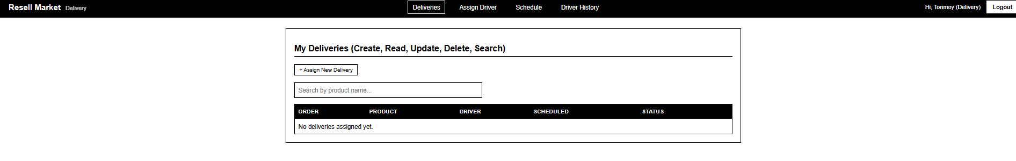
Figure 17: Delivery
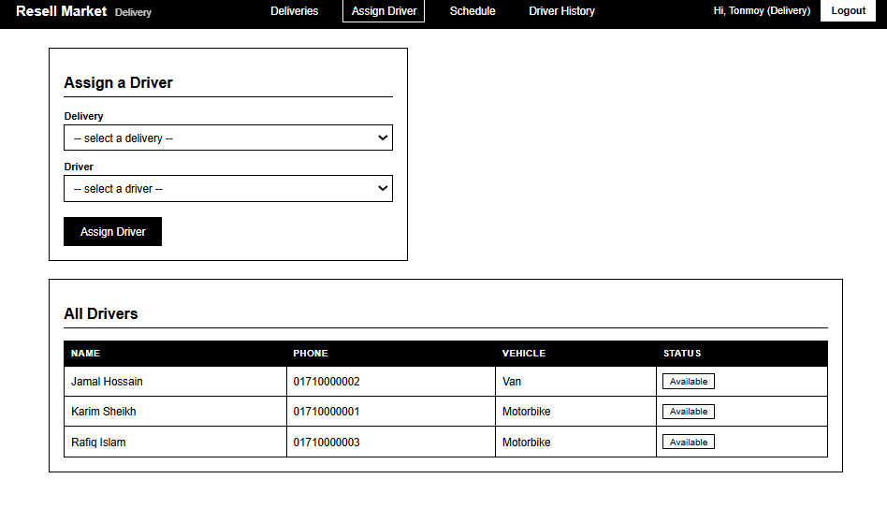
Figure 18: Assign Driver
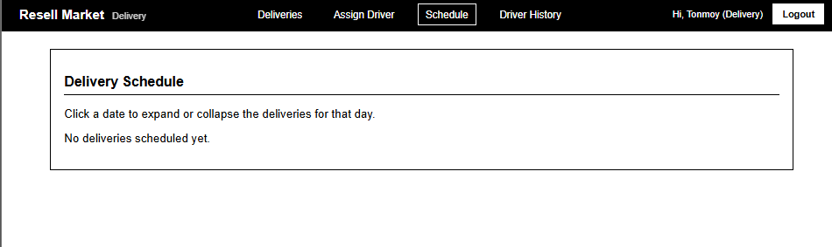
Figure 19: Schedule
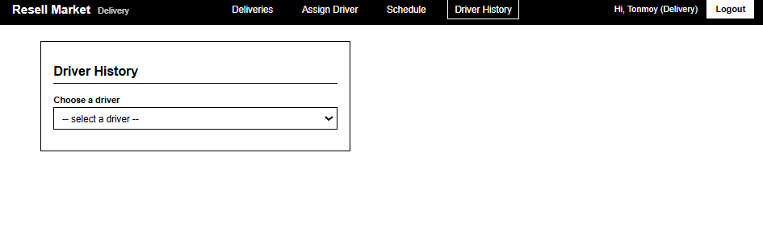Figure 20: Driver History

Provide the tentative design of your system.

Types of Users: 1. Admin 2. Seller 3. Buyer 4. Delivery Man
Common Features (Available to All Users)
- Authentication
- Login to the system
- Logout from the system
- User registration
- Account Management
- Change or reset password
- Manage profile information (view, edit, delete)
- Dashboard
- Access a personalized dashboard after login
Specific Features by User Type
- Features of Admin
- Manage all user accounts (add, edit, delete, search, and approve new registrations)
- Ban or unban a user for a set number of days
- Approve or reject products submitted by sellers, and view monthly revenue reports.

- Features of Seller
- Add, edit, delete, and search their own products
- Update product stock quantity and generate invoices for paid orders
- View low-stock notifications and mark them as read
- Features of Buyer
- Browse and search approved products, then place, edit, or cancel orders
- Make payments for orders using different payment methods
- Write reviews and ratings for products they have purchased
- Features of Delivery Man
- Create and update delivery records, and assign a driver to a delivery
- View and manage the delivery schedule
- View delivery history and track completed deliveries

